THE UNITED REPUBLIC OF TANZANIA

EASTERN AFRICA STATISTICAL TRAINING CENTRE

TASK: GROUP ASSIGNMENT 1
INSTRUCTOR: MR OMBEN E KALUSE
MODULE NAME: STATISTICAL INFERENCE
COURSE: BACHER DEGREE IN DATA SCIENCE (BDTS II)
MODULE CODE: DSU07318
GROUP NO: 65 & 66
MEMBERS

S/NO | NAME | REGISTRATION NUMBER
01 | RAHEL RICHARD KAPANGE | EASTC/BDTS/25/01861
02 | RAMADHAN BUNDALA CHARLES | EASTC/BDTS/25/02683
03 | RICHARD JUMA CHANDARAU | EASTC/BDTS/25/02404
04 | SAID MUSSA KANENGO | EASTC/BDTS/25/02610
05 | REBEKA JAMES BOMAN | EASTC/BDTS/25/02580
06 | MOHAMED JUMA BILIMWAMVUA | EASTC/BDTS/25/03011
07 | RAMADHAN KHAMIS RAMADHAN | EASTC/BDTS/25/01933
08 | NURIATH YASIN MSANGI | EASTC/BDTS/25/03015
09 | PAULO THADEO NDONNA | EASTC/BDTS/25/02487
10 | ISSA KASSIMU NACHIPYANGO | EASTC/BDTS/25/01196

SOFTWARE REQUIREMENTS SPECIFICATION FOR MICROFINANCE MANAGEMENT SYSTEM(MMS)

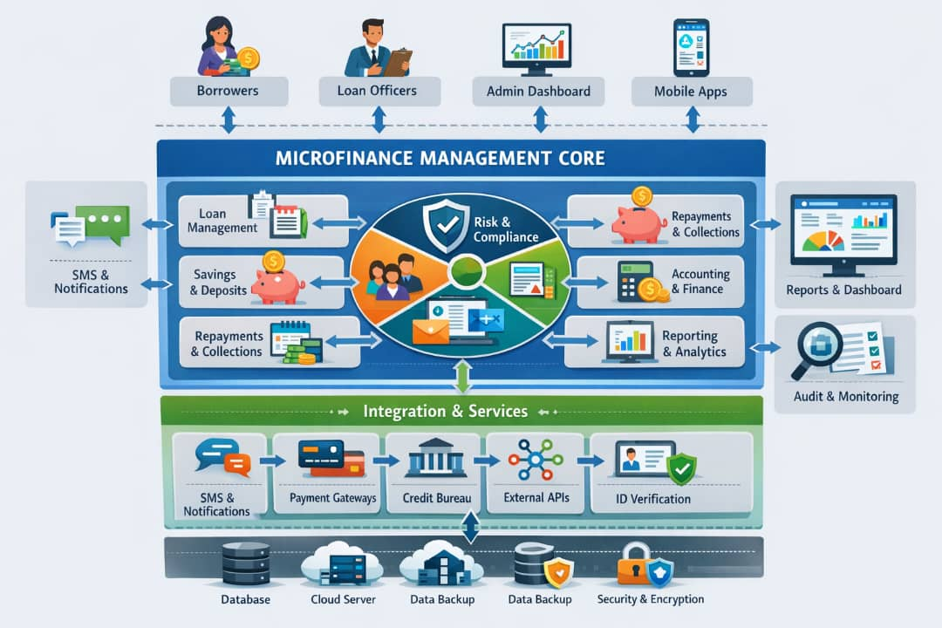
Contents
1. Introduction 4
1.1 Purpose 4
1.2 Scope 4
1.3 Users and Stakeholders 4
1.4 system overview 4
1.5 Definitions, Acronyms, and Abbreviations 5
3. Non-Functional Requirements 6
4. Domain Requirements 6
5. Technical Requirements 6
6. System Features 7
7. User Interface 7
8.system architecture 8
8.1 Presentation layer 8
8.2 Application Layer (Business Logic Layer) 8
8.3 Services / API Layer (Integration Layer) 9
8.4 Data Layer (Database Layer) 9
8.5 Security Layer (Cross-cutting Layer) 10
8.6 Reporting & Analytics Layer 10
9. Assumptions and Dependencies 10
10. references 11

1. Introduction

1.1 Purpose
The Microfinance System is a digital platform designed to provide financial services to low-income individuals and small businesses in Tanzania. The system aims to promote financial inclusion, poverty reduction, and economic empowerment.

1.2 Scope
The Microfinance management System (MMS) will provide a comprehensive platform for managing client information, loan applications, savings accounts, and transactions. The system will support the organization's mission to deliver efficient and effective financial services to its clients.

1.3 Users and Stakeholders

- Clients: Low-income individuals and small businesses
- Loan Officers: Responsible for managing loan applications and client interactions
- Accountants: Responsible for managing transactions and financial reporting
- Administrators: Responsible for system configuration and user management

1.4 system overview
MMS for an organization in small and large microfinance center the system will manage client’s information, loan application, savings account and transactions.

1.5 Definitions, Acronyms, and Abbreviations
- MMS: - Microfinance Management System
- ATM: - Automatic Teller machine
- OTP: - One Time password
- RBAC: -Role-based access control
- PAR: - Portfolio At Risk

2. Functional Requirements

- Client Management:
- Register new clients and assign unique ID
- Manage client demographics, loan history, and savings accounts
- Loan Management:
- Process loan applications and approvals
- Manage loan disbursements and repayments
- Support group lending with joint liability and peer pressure mechanisms
- Savings Management:
- Manage client savings accounts and transactions
- Support deposits, withdrawals, and transfers
- Transaction Management:
- Process transactions (deposits, withdrawals, loan repayments)
- Generate receipts and transaction history
- Group Lending Features& Management
- Group Creation: Create and manage groups of clients for joint liability loans
- Joint Liability: Track and manage joint liability for group loans
- Peer Pressure Mechanisms: Send reminders and notifications to group members for timely repayment
- Social Collateral: Track and manage social collateral for group loans

3. Non-Functional Requirements
- Security
- Comply with Tanzanian data protection laws and regulations
- Implement role-based access control and authentication
- Performance:
- Fast response time (<2 seconds)
- High availability (99.9% uptime)
- Usability:
- Intuitive and user-friendly interface for loan officers and clients
- Support for Swahili language

4. Domain Requirements
- Compliance with Tanzanian Microfinance Regulations (Bank of Tanzania guidelines)
- Local Language Support (Swahili interface and client records)
- Integration with Local Payment Systems (e.g., mobile money, bank transfers)

5. Technical Requirements

- Programming Language: Java, Python, or JavaScript
- Database: MySQL, PostgreSQL, or MongoDB
- Server: Apache Tomcat, Nginx, or AWS EC2
- API: RESTful API using JSON or XML for web and mobile applications

6. System Features

- Client Dashboard:
- Display client information, loan history, and savings accounts
- Provide alerts and notifications for loan repayments and savings milestones
- Loan Application and Approval:
- Support online loan applications and approvals
- Automate loan disbursements and repayments
- Group Lending Module:
- Create and manage groups for joint liability loans
- Track and manage joint liability and peer pressure mechanisms

7. User Interface

- Design:
- Clean, simple, and intuitive design
- Consistent branding and color scheme
- Navigation:
- Easy navigation and access to system features
- Support for multiple languages (English, Swahili)

8.system architecture
This describes the whole application of a microfinance management system as follows

8.1 Presentation layer
The microfinance management system (MMS) will allow the following users;
- Loan officers
- Branch managers
- Accountants
- Administrators
- Clients (USSD)

The microfinance management system (MMS) will perform the following
- Provides screens and forms for:
Client registration
- Loan application & approval
- Savings deposits & withdrawals
- Repayment tracking
- Reports and dashboards
Examples
Web application (browser-based)
Mobile app (Android)
USSD/SMS interface for clients with basic phones

8.2 Application Layer (Business Logic Layer)
This is the brain of the Microfinance management system (MMS).
This layer has the following responsibility such as
- Loan eligibility checks
- Interest calculation
- Repayment schedule
- Controls workflows:
- Loan approval process
- Savings transactions
- Account status changes
- Typical modules
- Client Management Module
- Loan Management Module
- Savings Management Module
- Repayment and Penalty Module

8.3 Services / API Layer (Integration Layer)
This layer connects Microfinance system with external systems.
Integrations include
- Mobile Money APIs (M-Pesa, Airtel Money, Tigo Pesa)
- Bank APIs
- SMS & Email gateways
- Credit reference bureaus (if applicable)
- Function of a system
- Sends payment requests
- Receives confirmation callbacks
- Sends SMS alerts (loan approved, payment received)
- Enables third-party apps to interact securely

8.4 Data Layer (Database Layer)
This is where all system data is stored.
- Key databases
- Client database
- Loan records
- Savings accounts
- Transactions
- Repayment history
- Typical technologies
- Relational DB: MySQL / PostgreSQL and
- Optional NoSQL: MongoDB (for logs, analytics)

8.5 Security Layer (Cross-cutting Layer)
This layer protects every other layer from not accessed by unauthorized, by containing
- Security mechanisms
- User authentication (username/password, OTP)
- Role-Based Access Control (RBAC)
- Data encryption (at rest & in transit)
- Audit trails (who did what and when)

8.6 Reporting & Analytics Layer
This layer supports decision making like,
- Reports generated
- Portfolio at Risk (PAR)
- Loan disbursement reports
- Repayment performance
- Savings growth
- Branch & staff performance
- Tools
- Built-in reports and export to Excel / PDF
- Dashboards with charts

9. Assumptions and Dependencies

- Assumptions:
- The organization has a reliable internet connection and adequate IT infrastructure
- Users have basic computer skills and familiarity with digital systems
- Dependencies
- Integration with local payment systems and mobile money providers
- Compliance with regulatory requirements (Bank of Tanzania, data protection laws)

10. references
Official Software / System Websites
MFSYS Microfinance System – Core banking & microfinance solutions:
- https://mfsys.ca/www.com
Misys
Loan disk – Online loan & microfinance management platform:
- https://www.loandisk.com/www.com
Loan disk
Brit Software (Microfinance loan management) – Cloud-native microloan solution:
- https://www.brytsoftware.com/microfinance
Brit Software
Musoni System – Digitalization partner & microfinance platform:

PREPARED BY: group number 65 & 66

DATE:23^{rd December} 2025

